1. Write a Shell Script to check whether a number is negative, positive or zero.

Ans: 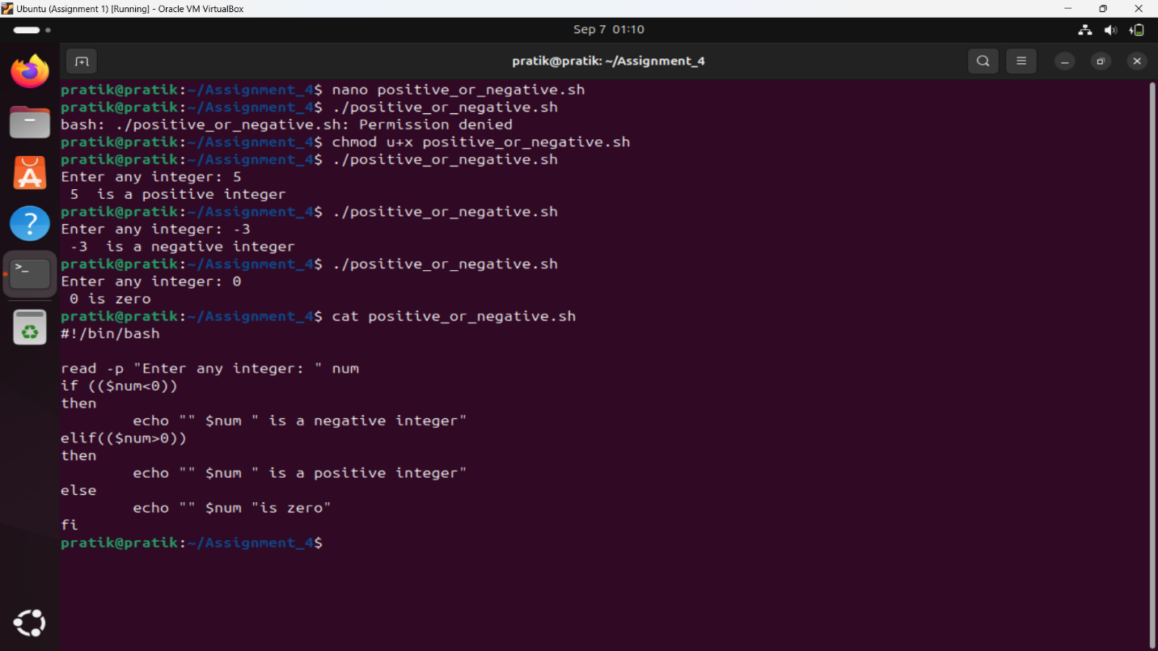

2. Write a Shell Script to check whether a number is divisible by 5 and 11 or not.

Ans:

3. Write a Shell Script to check whether a number is even or odd.

Ans:

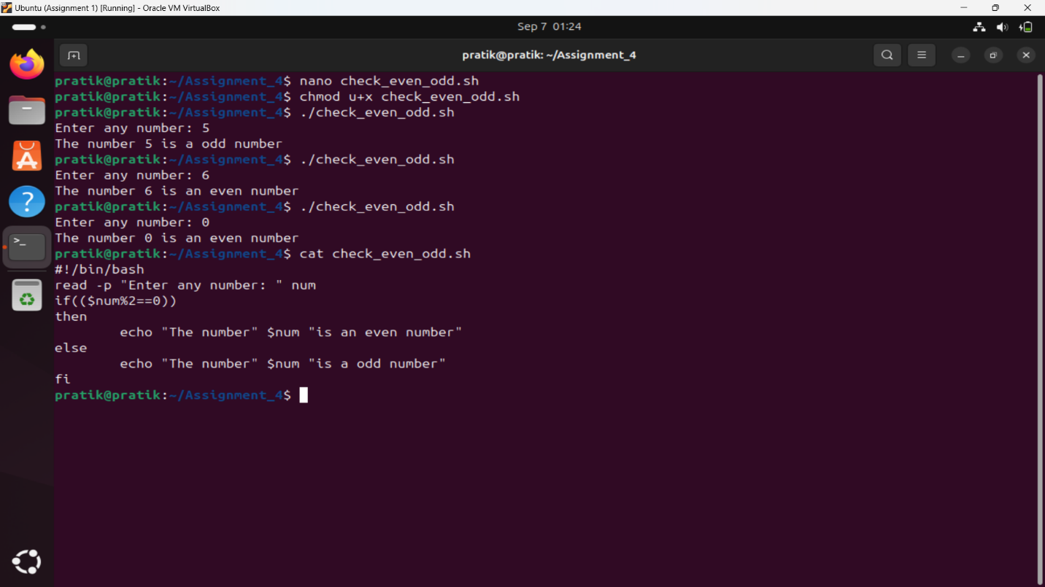

4. Write a Shell Script to check whether a year is leap year or not.

Ans:

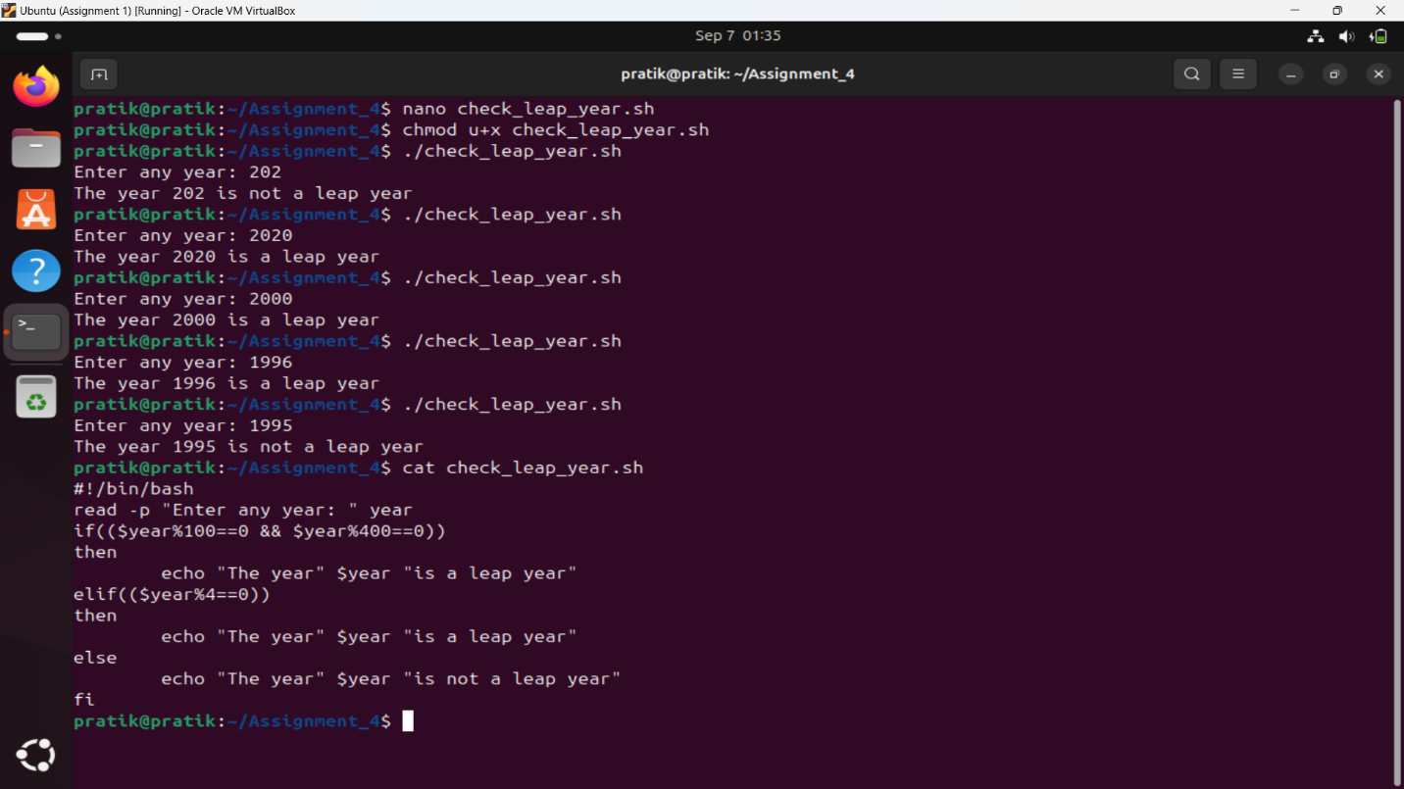

5. Shell Script to print number between 1 to 10 in character format using switch-case.

Ans:

6. Shell Script to accept id from user to confirm department using switch-case.

Ans:

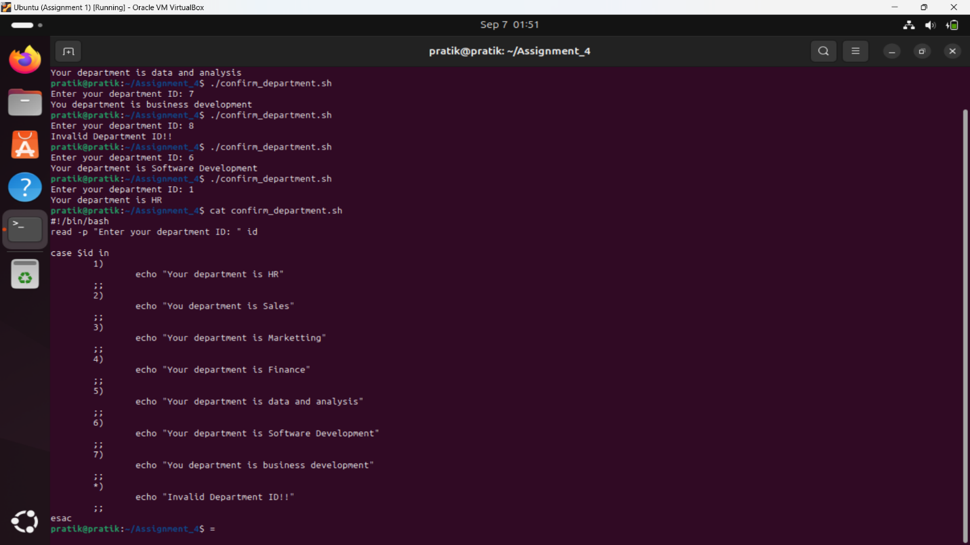

7. Shell Script to check password is correct or incorrect using switch-case.

Ans:

8. Shell Script to print day of week using switch-case.

Ans:

9. Shell Script to create calculator using switch-case.

Ans:

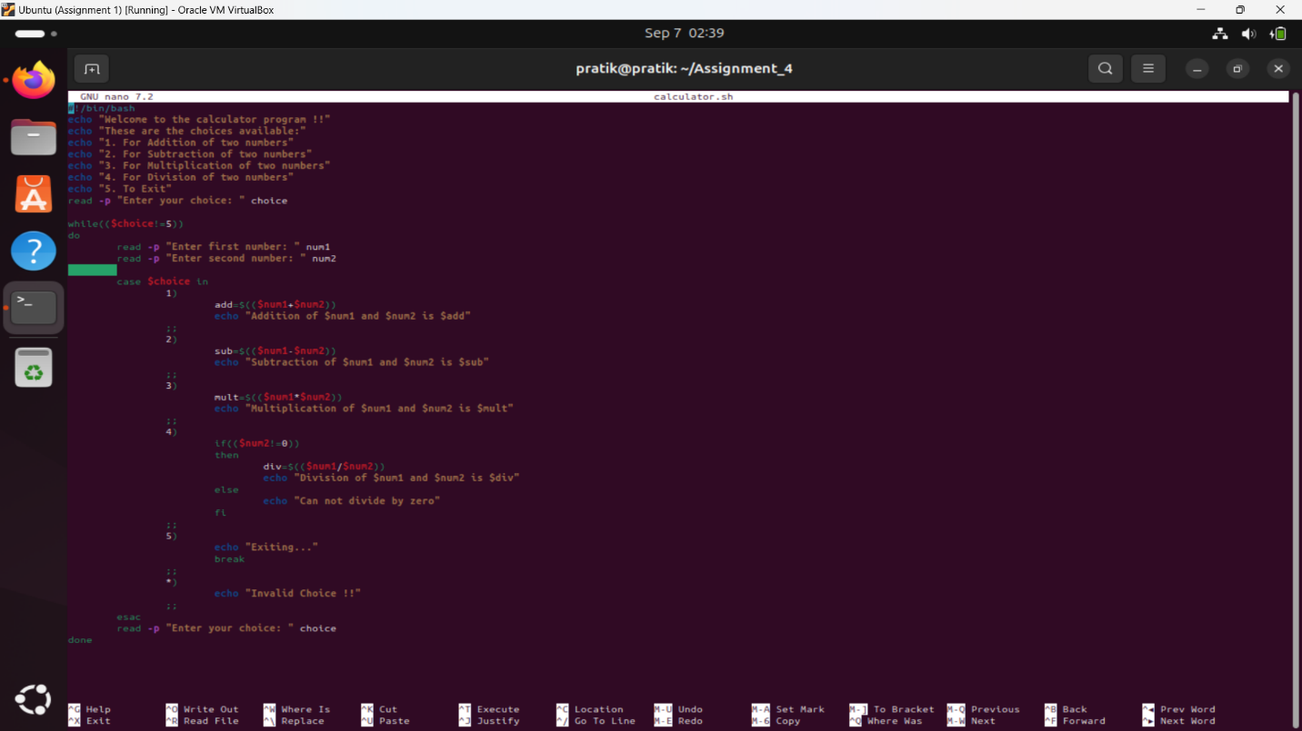

10. Write a shell script to create a menu driven program for adding, deletion or finding a record in a database. Database should have the field like rollno, name, semester and marks of three subjects. Last option of the menu should be to exit the menu.

Ans:

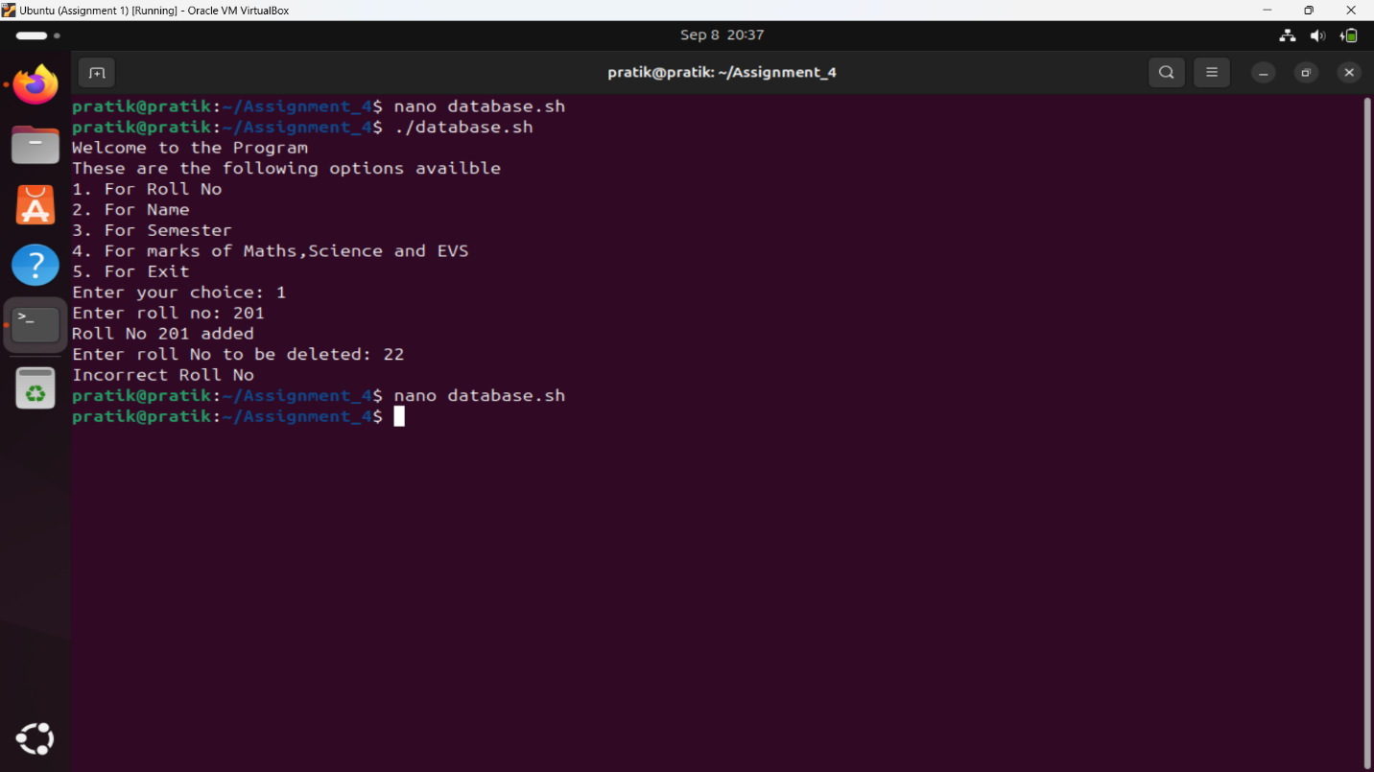

11. Write a Linux shell script to accept 10 number and tell how many are +tive, -tive and zero.

Ans:

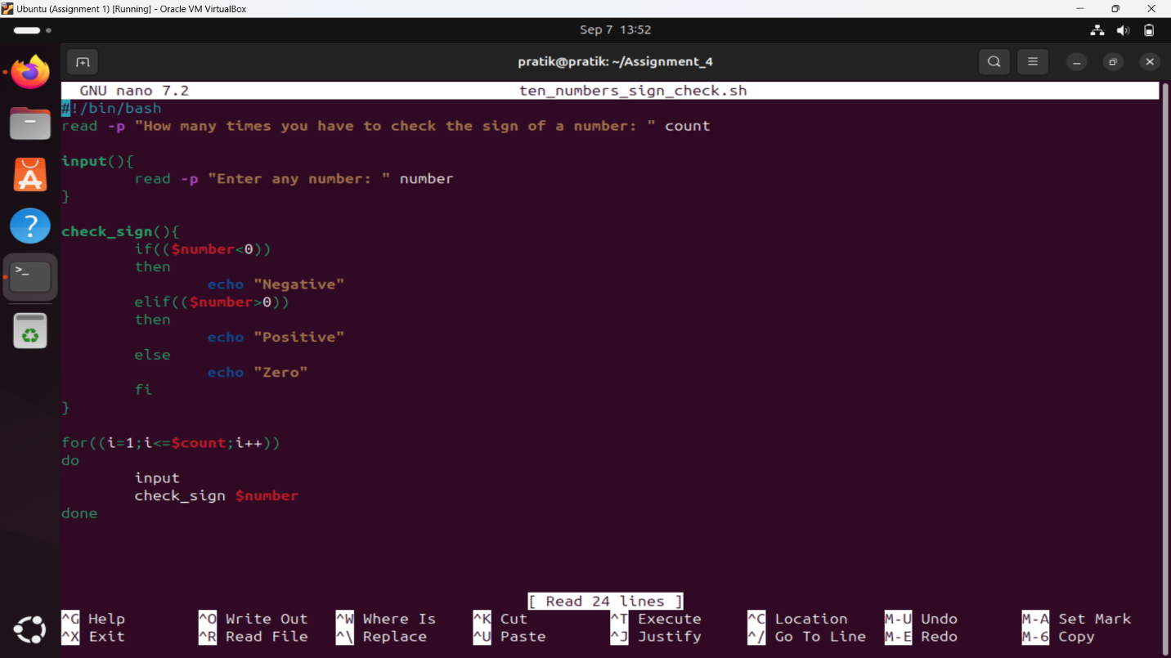

12. Write a shell script to accept five number and display max and min value.

Ans:

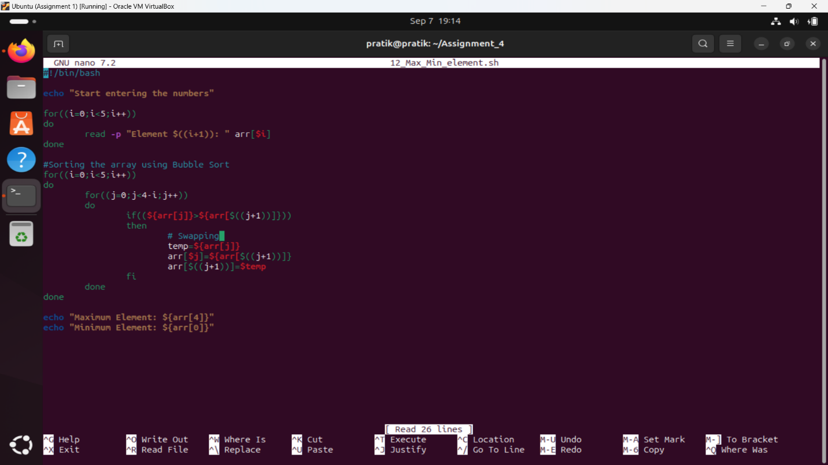

13. Write a script to find out String is palindrome or not.

Ans:

14. Write a shell script to print given number’s sum of all digits (eg. If number is 123, then it’s sum of all digits will be 1+2+3=6)

Ans:

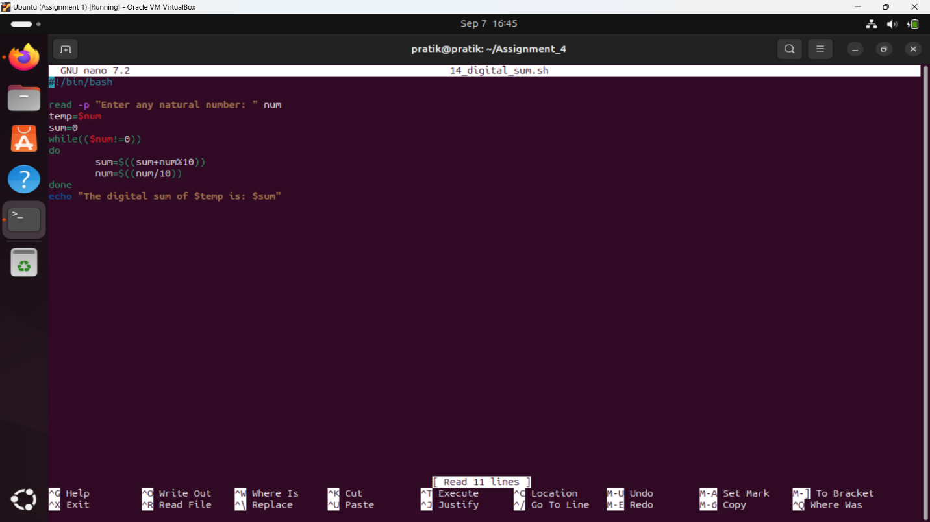

15. Create a script to

Create user , Delete user , Create group , delete Group using case

Ans:

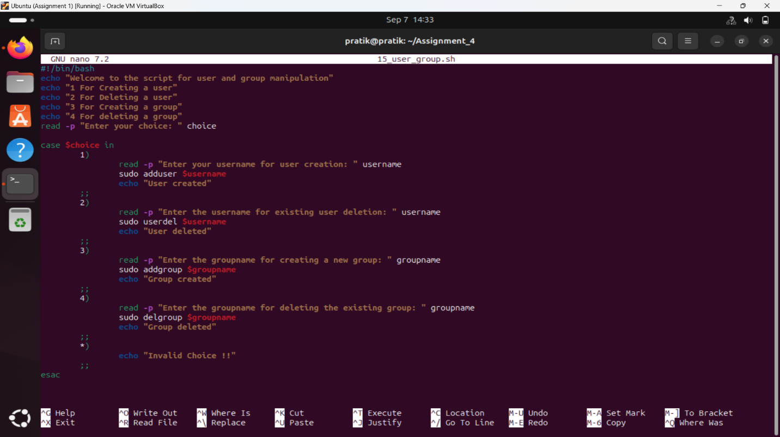

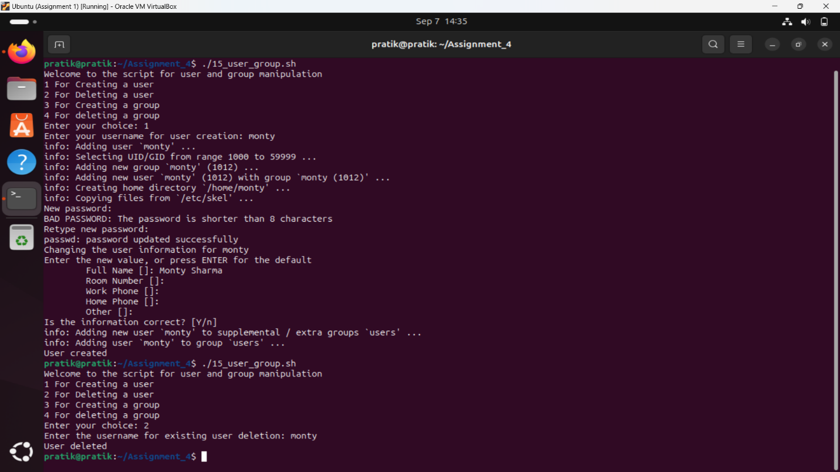

16. Shell Script to compute the sum of the first 10 natural numbers.

Expected Output :

The first 10 natural number is :

1 2 3 4 5 6 7 8 9 10

The Sum is : 55

Ans:

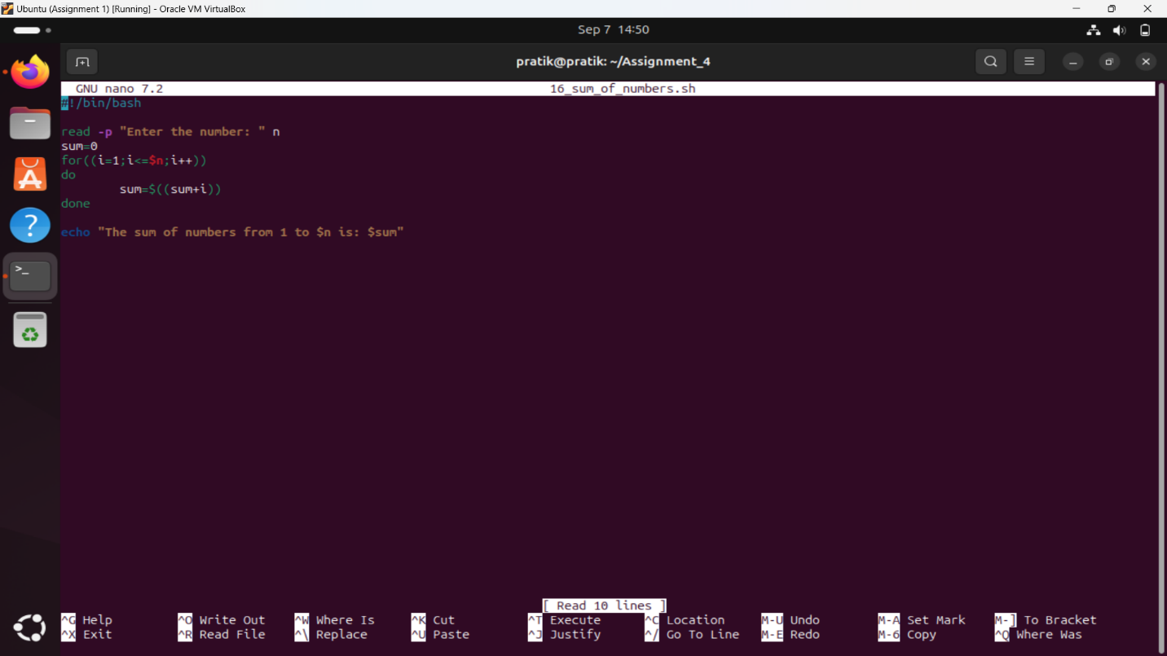

17.  Shell Script to display n terms of natural numbers and their sum.

Test Data : 7

Expected Output :

The first 7 natural number is :

1 2 3 4 5 6 7

The Sum of Natural Number upto 7 terms : 28

Ans:

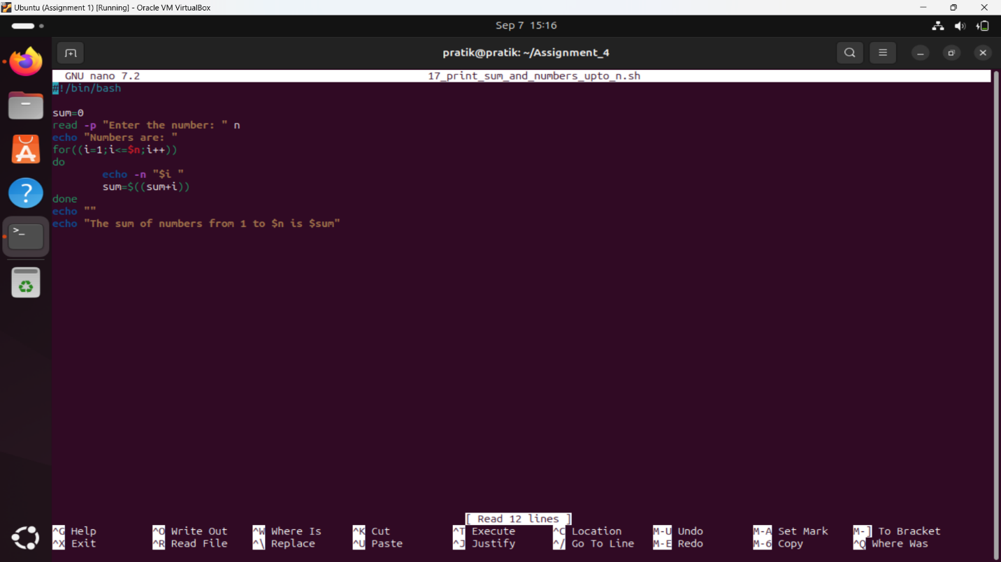

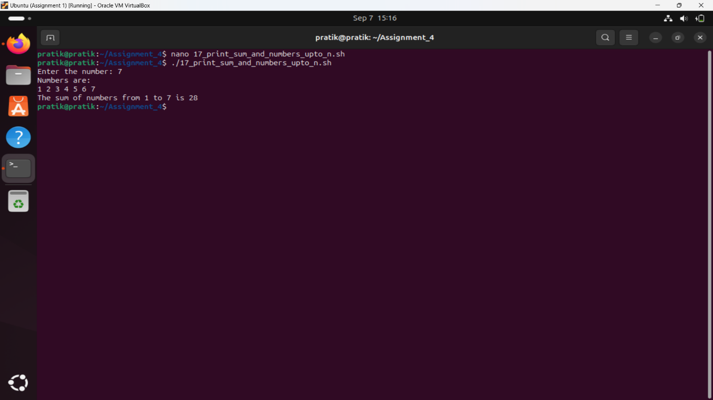

18. Shell Script to read 10 numbers from the keyboard and find their sum and average.

Test Data :

Input the 10 numbers :

Number-1 :2

...

Number-10 :2

Expected Output :

The sum of 10 no is : 55

The Average is : 5.500000

Ans:

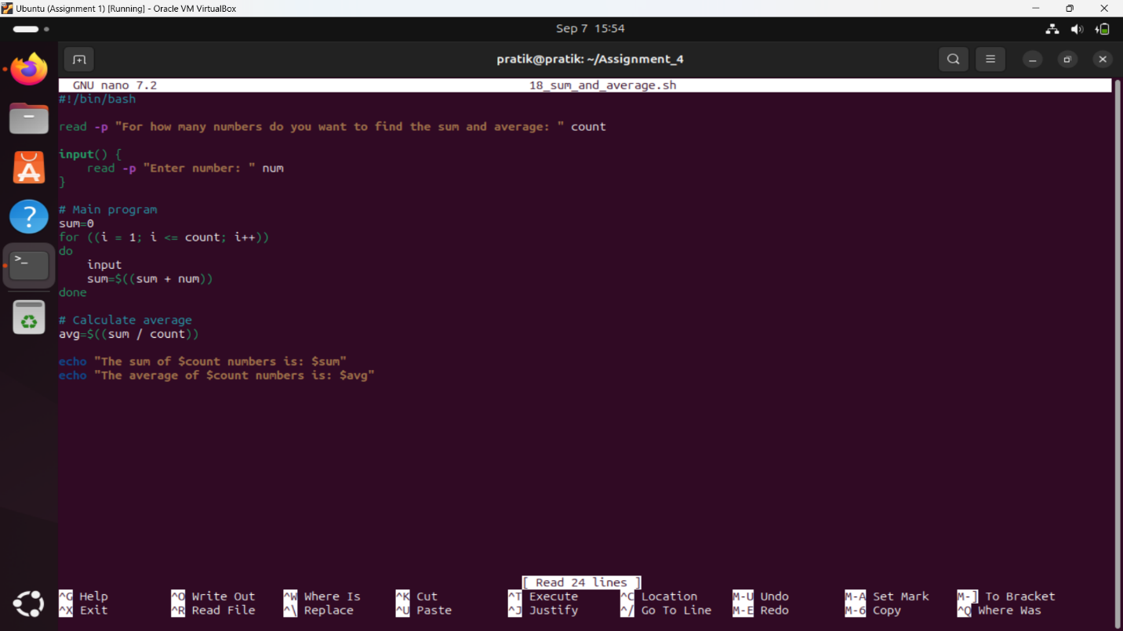

19. Shell Script to display the cube of the number up to an integer.

Test Data :

Input number of terms : 5

Expected Output :

Number is : 1 and cube of the 1 is :1

Number is : 2 and cube of the 2 is :8

Number is : 3 and cube of the 3 is :27

Number is : 4 and cube of the 4 is :64

Number is : 5 and cube of the 5 is :125

Ans:



